**Project Design Phase-II**

**Technology Stack (Architecture & Stack)**

|  |  |
| --- | --- |
| Date | 03 October 2022 |
| Team ID | PNT2022TMID35939 |
| Project Name | Project – Medicine Reminder |
| Maximum Marks | 4 Marks |

**Technical Architecture:**

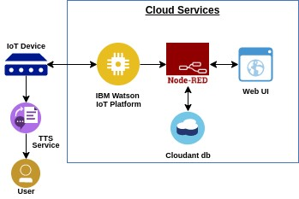

**Table-1 : Components & Technologies:**

|  |  |  |  |
| --- | --- | --- | --- |
| **S.No** | **Component** | **Description** | **Technology** |
| 1. | User Interface | User interacts with application i.e., Mobile App, Web UI | MIT App Inventor(blocks coding) |
| 2. | Application Logic-1 | Logic for a process in the application | Python |
| 3. | Application Logic-2 | Logic for a process in the application | IBM Watson IoT Platform |
| 4. | Application Logic-3 | Logic for a process in the application | Node-Red services |
| 5. | Application Logic-4 | Logic for a process in the application | Text To Speech(TTS) Services |
| 6. | Database | Data Type, Configurations etc. | NoSQL |
| 7. | Cloud Database | Database Service on Cloud | IBM Cloudant |
| 8. | File Storage | File storage requirements | IBM Block Storage or Other Storage Service or Local Filesystem |
| 9. | External API-1 | Purpose of External API used in the application | IBM Weather API, etc. |
| 10. | Infrastructure (Server / Cloud) | Application Deployment on Local System / Cloud Local Server Configuration:  Cloud Server Configuration : | Cloud Foundry, Kubernetes |

**Table-2: Application Characteristics:**

|  |  |  |  |
| --- | --- | --- | --- |
| **S.No** | **Characteristics** | **Description** | **Technology** |
| 1. | Open-Source Frameworks | List the open-source frameworks used | IBM Watson |
| 2. | Security Implementations | List all the security / access controls implemented, use of firewalls etc. | Encryptions, ISO 27001 |
| 3. | Scalable Architecture | Justify the scalability of architecture (3 – tier, Micro-services) | Cloud Services |
| 4. | Availability | Justify the availability of application (e.g. use of load balancers, distributed servers etc.) | Software services |
| 5. | Performance | Design consideration for the performance of the application (number of requests per sec, use of Cache, use of CDN’s) etc. | Number of time and medicine settings |